**EXPERIMENT 1**

**USN: 1BM21CS231**

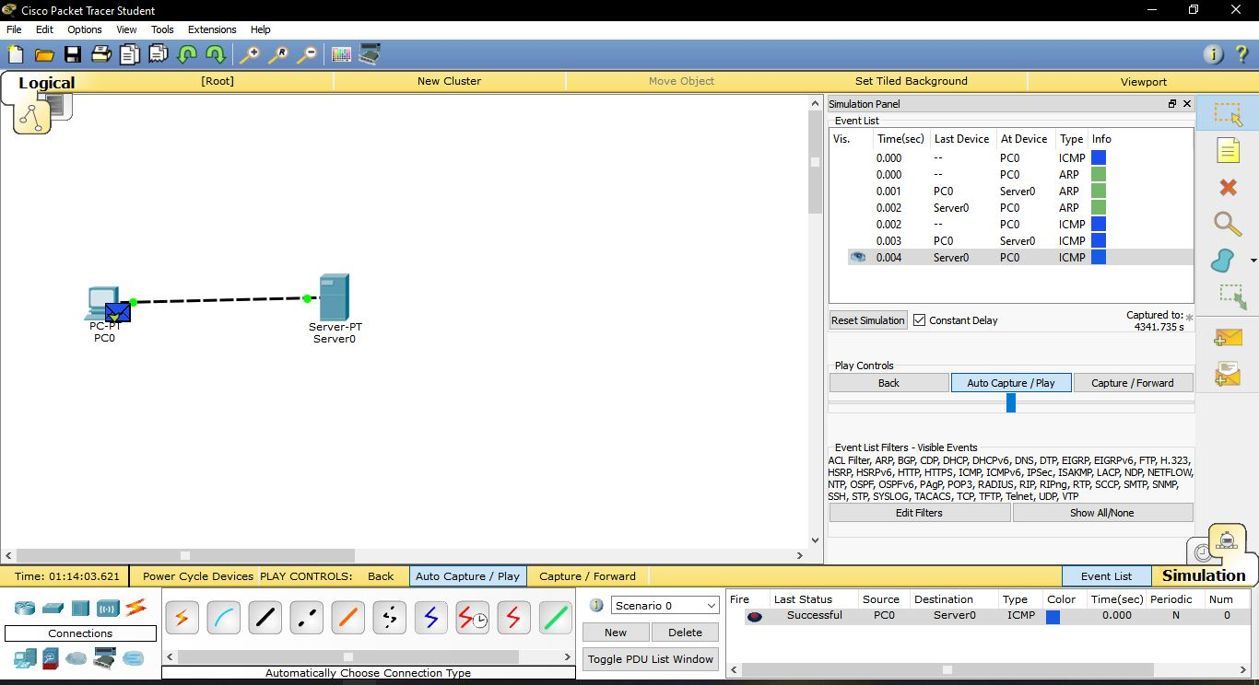

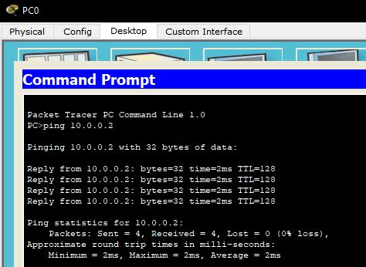

**PING FOR CONFIGURED IP ADDRESS**

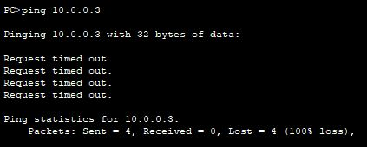

**PING FOR IP ADDRESS WHICH IS NOT CONFIGURED**

